**CSS Notes**

1. To get inline structures to push down with **margin-top** or **padding-top** use **display: block-inline;**
2. Lego structure
   1. In body create div with id container
   2. In container create header and main tags
   3. In main create div’s with id row-1 and row-2
   4. In row-2 create three div’s without an id

<body>

<div id="container">

<!-- top of page -->

<header>

<!-- ... -->

</header> <!-- header -->

<!-- main container -->

<main>

<div id="row-1">

<!-- upper-left image -->

<img src="img.jpg" alt="img not found">

<!-- <div class="row-1">

</div> <!-- row-1 -->

<!-- upper-right box -->

<div>

</div> <!-- end upper-right box -->

</div> <!-- row-1 -->

<div id="row-2">

<div> </div>

<div> </div>

<div> </div>

</div> <!-- row-2 -->

</main> <!-- end main-container -->

</div> <!-- container -->

</body>

1. Transparency:
   1. In content add the following:

#container {

/* background: red; */

height: 1000px;

width: 1013px;

/* DEBUG */

background-image: url("spec.png");

background-size: contain;

background-repeat: no-repeat;

}

1. Position blocks on same line (within a row-div)

Try

display: inline-block;

vertical-align: top;

1. Columns in second row:
   1. Start with a row with three 100x100 blocks

/* ------------------------------------------------------------------ */

#row-2 {

/* DEBUG */

background: yellow;

opacity: 0.5;

height: 600px;

}

#row-2 div {

background: red;

height: 100px;

width: 100px;

margin-top: 5px;

margin-right: 5px;

margin-left: 5px;

display: inline-block;

vertical-align: top;

/* DEBUG */

opacity: 0.5;

}

/* ------------------------------------------------------------------ */

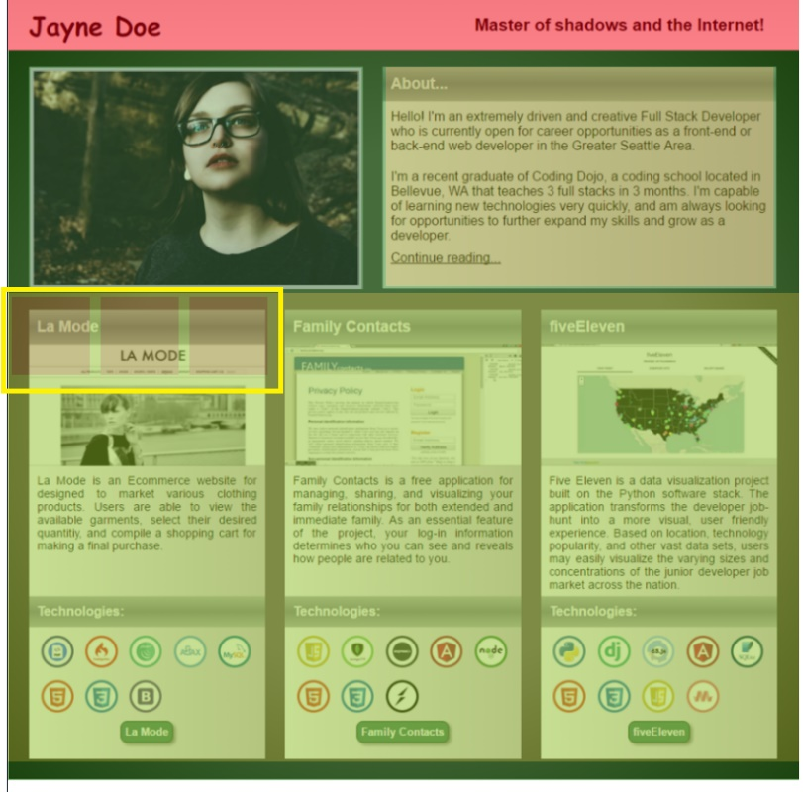

* 1. Adjust margin-left to get the first block into left column

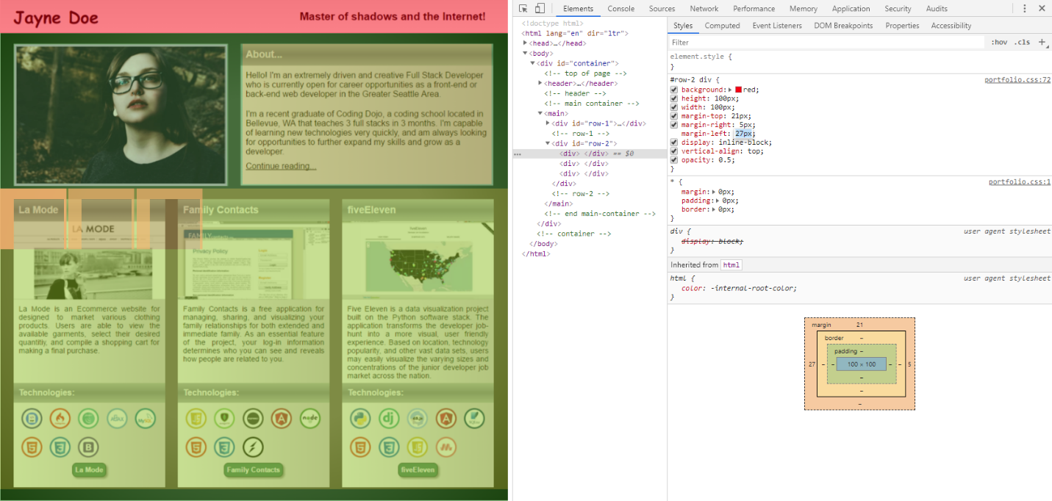

* 1. Adjust height and width

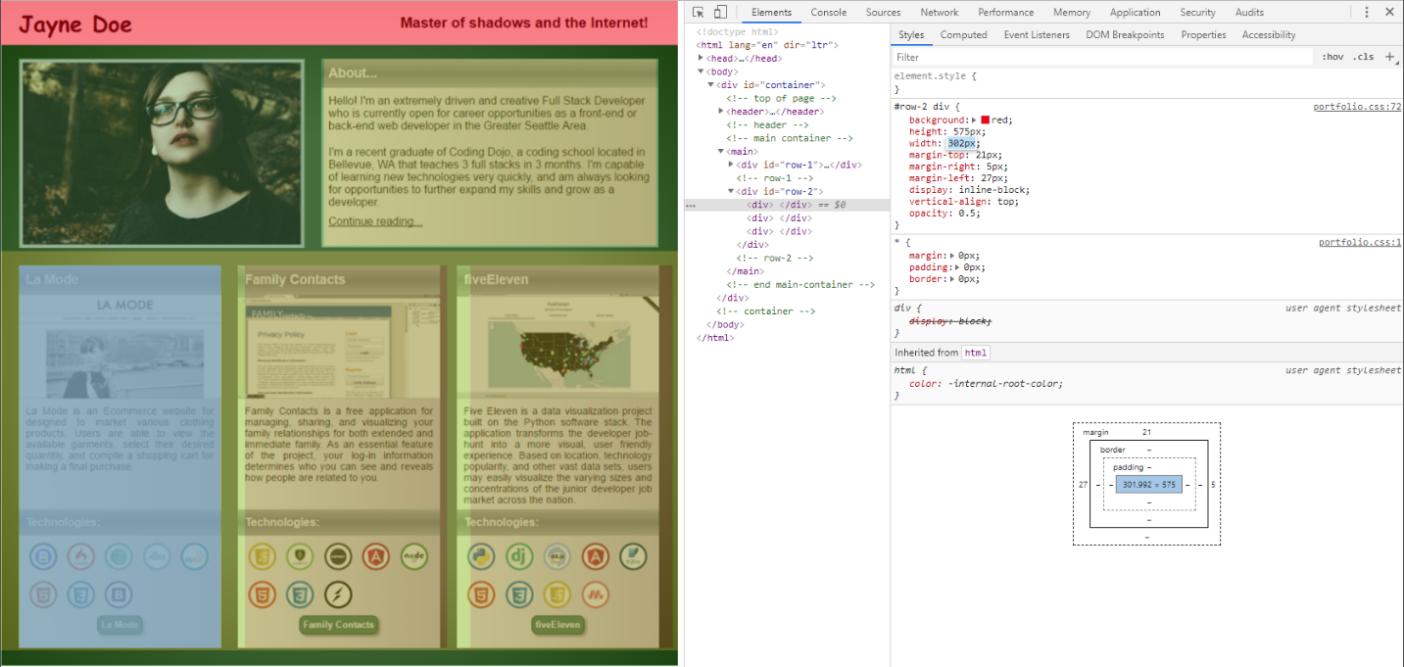

* 1. Adjust margin-right to separate the three blocks appropriately

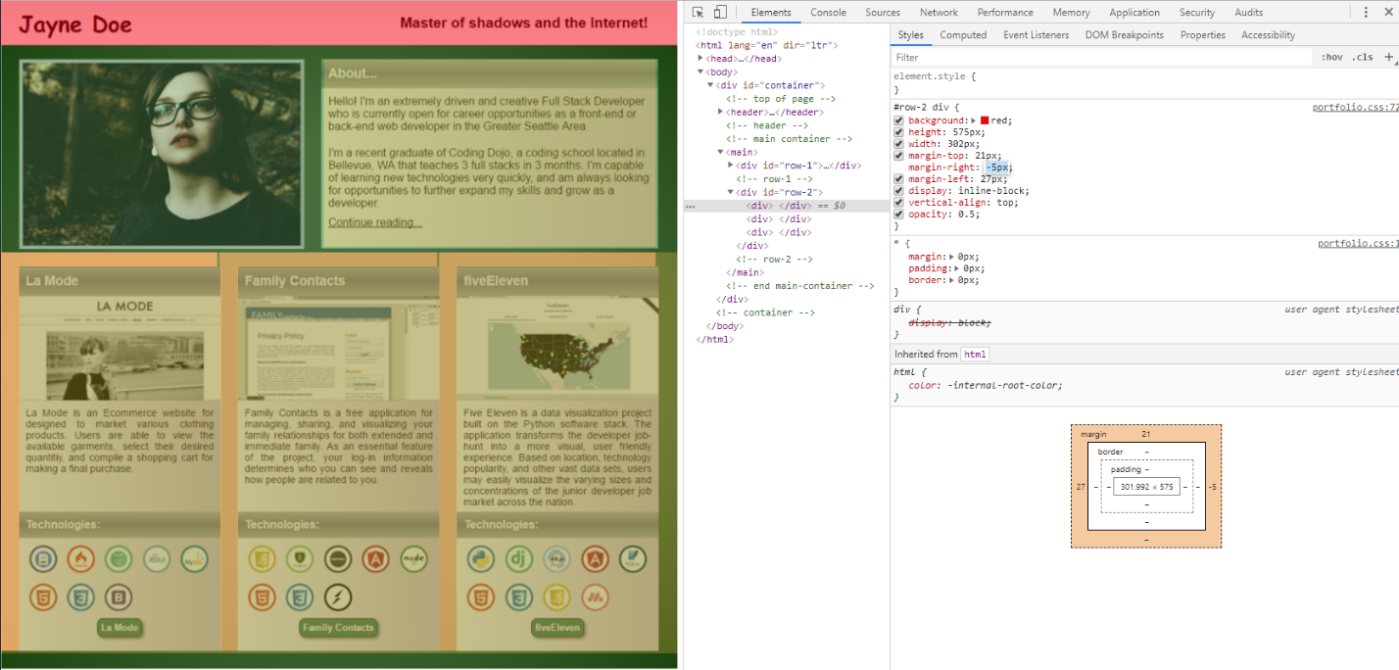

* 1. Add in two row in each column

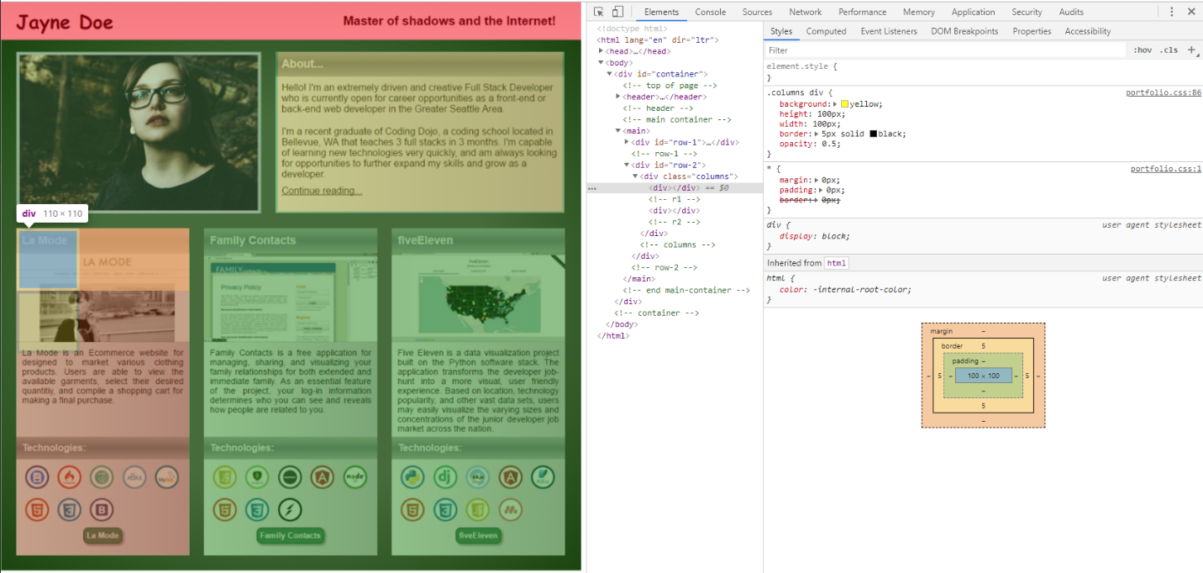

* 1. Increase height of first row

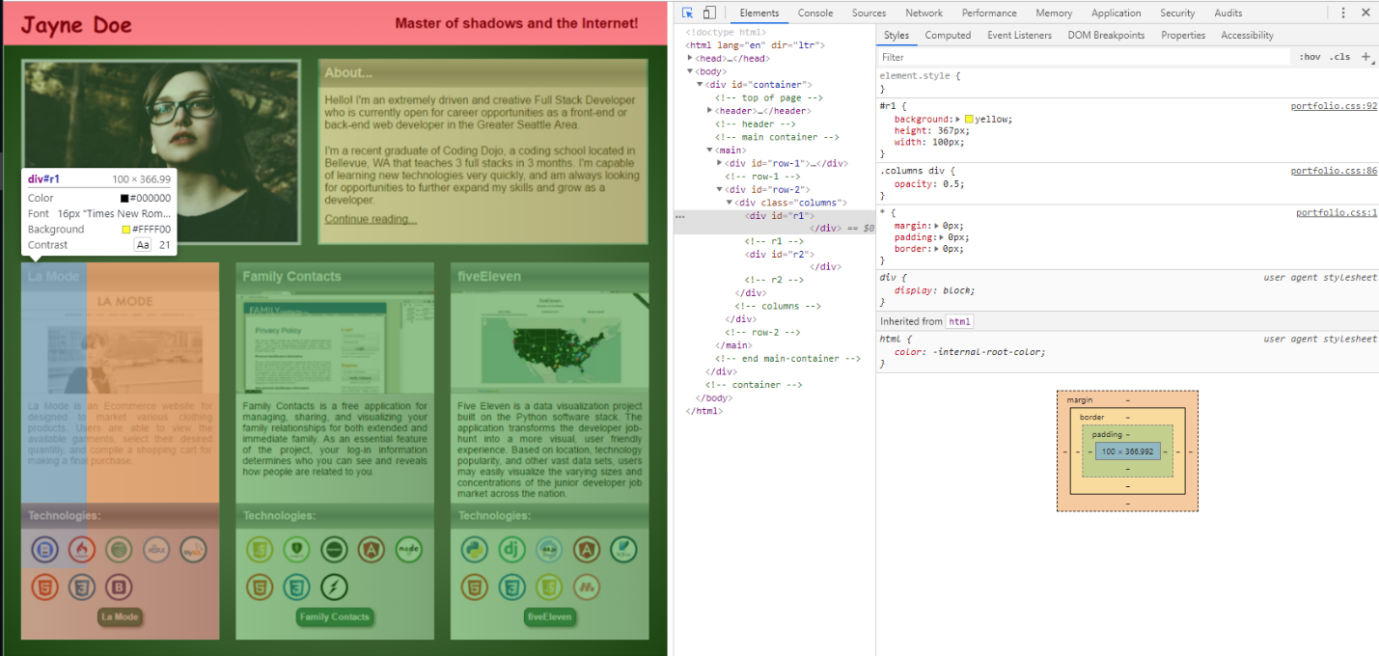

* 1. Increase height of second row
  2. Increase width of both rows in col

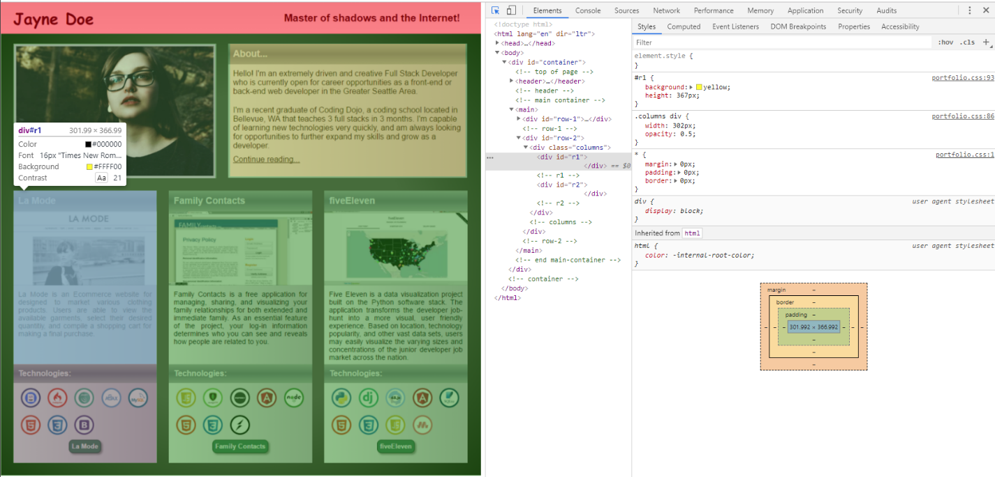

* 1. Add in text at top of first column top box and adjust margin on all sides.

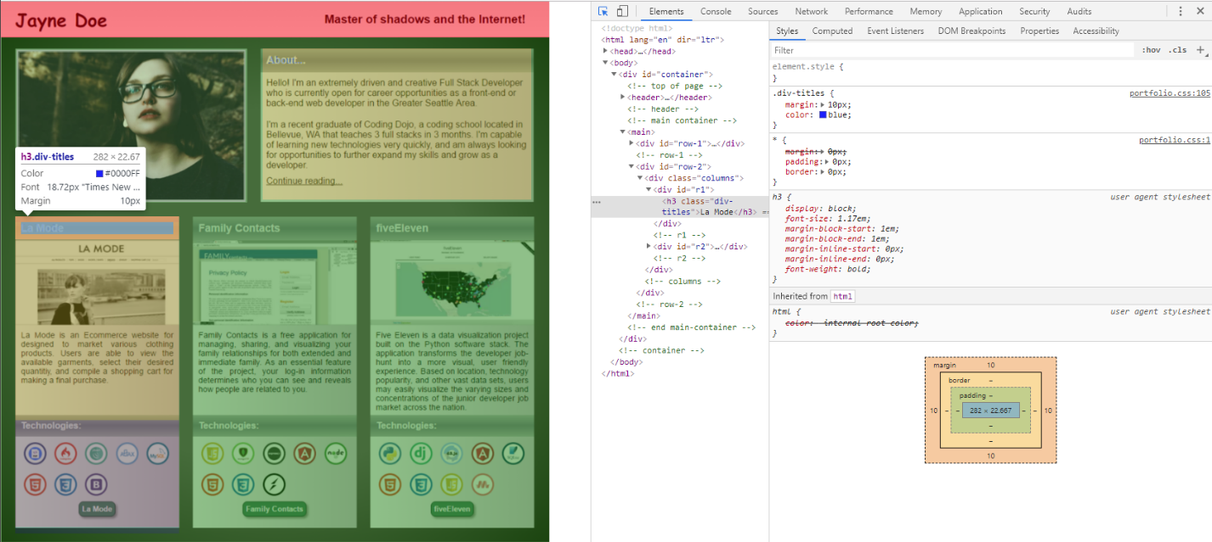

* 1. Add gradient to text and adjust height and **padding** of text

.div-titles-text {

background-image: linear-gradient(#B4B4B7, #888894, #B3B3B5);

height: 25px;

margin-top: 0px;

padding: 10px

}

* 1. Repeat for Technologies text. Use same class but next level down h-tag.

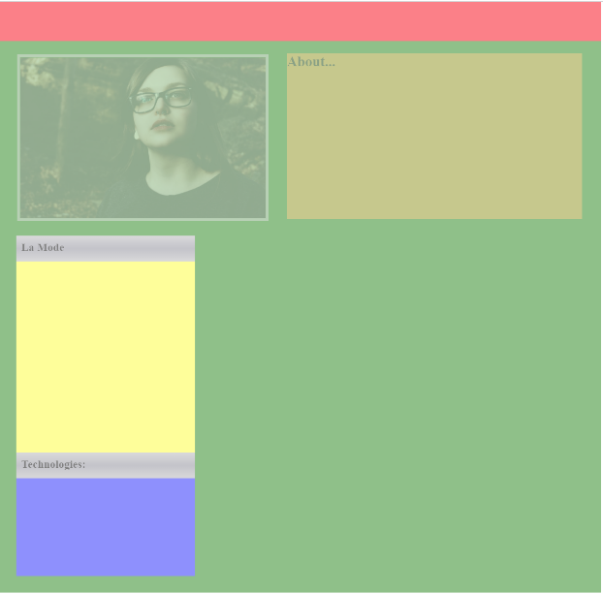

* 1. Add in images and adjust height, margin-top, margin left

#r2 img {

height: 40px;

margin-top: 11px;

margin-left: 14px;

}

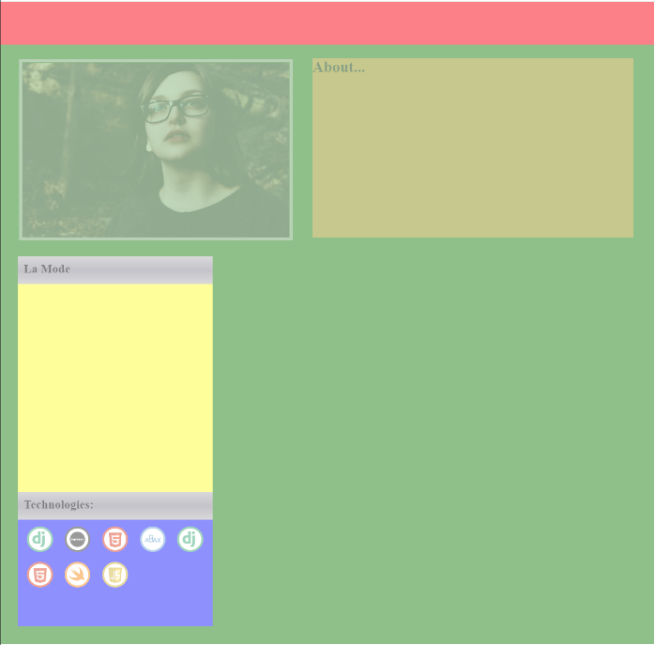 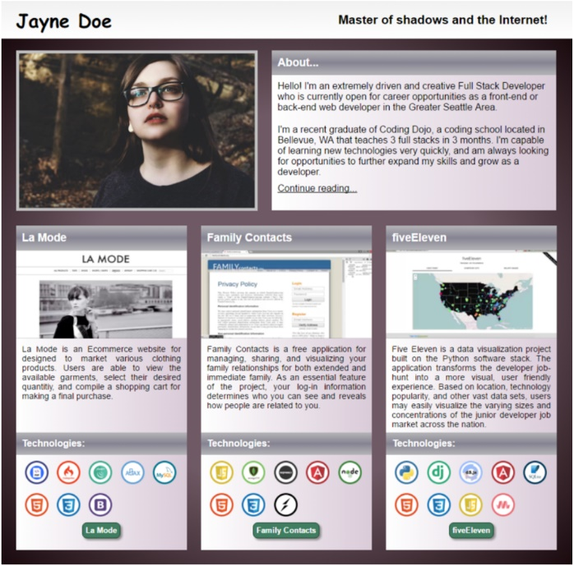

* 1. Add la-mode link
     + Add a-tag at same level as images.

<div id="**r2**">

<h3 class="div-titles-text" id="tech-text">Technologies:</h3>

<img src="Portfolio_images\django.png" alt="">

<img src="Portfolio_images\expressjs.png" alt="">

<img src="Portfolio_images\html.png" alt="">

<img src="Portfolio_images\ajax.png" alt="">

<img src="Portfolio_images\django.png" alt="">

<img src="Portfolio_images\HTML.png" alt="">

<img src="Portfolio_images\iOS-Swift.png" alt="">

<img src="Portfolio_images\JavaScript.png" alt="">

**<a href=""> </a>**

</div> <!-- **r2** -->

* + - **CSS display: block** to get it on next line
    - **CSS display: box-shadow** to
    - Use transparent background with shadow set to opposite color of desired shadow (i.e. set to white)
    - Play with settings in browser inspector

#r2 a{

background: orange;

height: 26px;

width: 68px;

display: block;

border-radius: 7px;

margin-top: 11px;

margin-left: 117px;

box-shadow: 8px 4px 5px 0px black

}

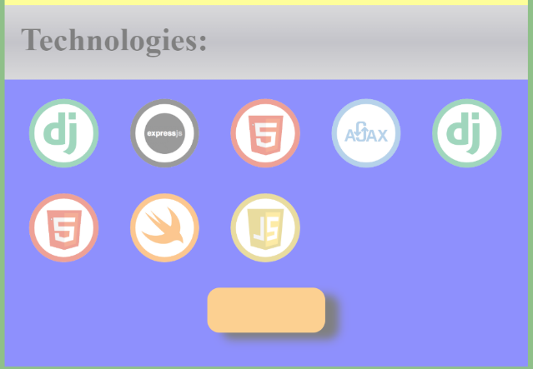 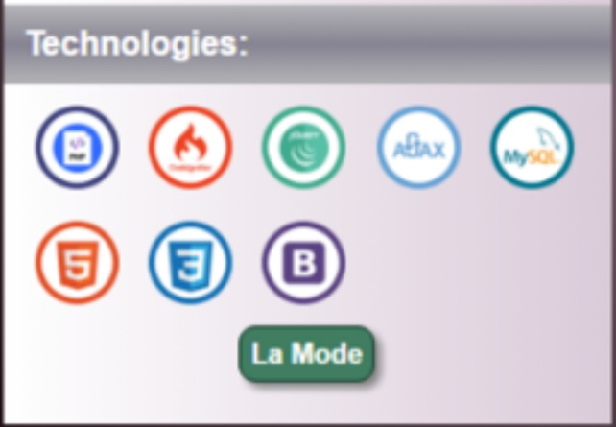

* 1. Change button to green with white text
     + Add border
     + Modify text

#r2 a {

background: green;

height: 22px;

width: 60px;

display: block;

border-radius: 7px;

margin-top: 10px;

margin-left: 117px;

box-shadow: 8px 4px 5px 0px black;

border: 1px black solid;

text-decoration: inherit;

color: white;

padding-top: 5px;

padding-left: 6px;

font-family: sans-serif;

font-size: 14px;

}

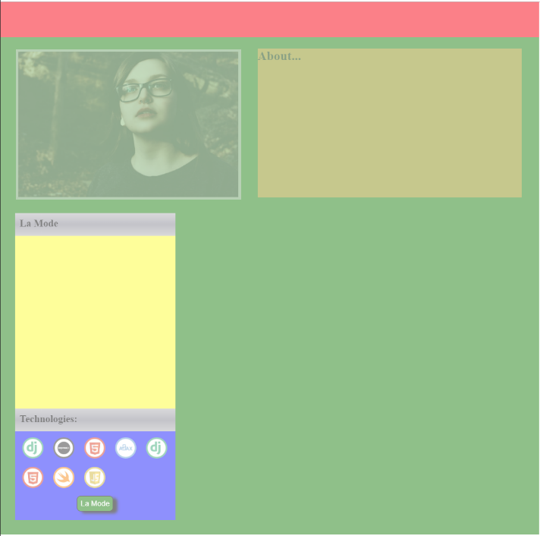 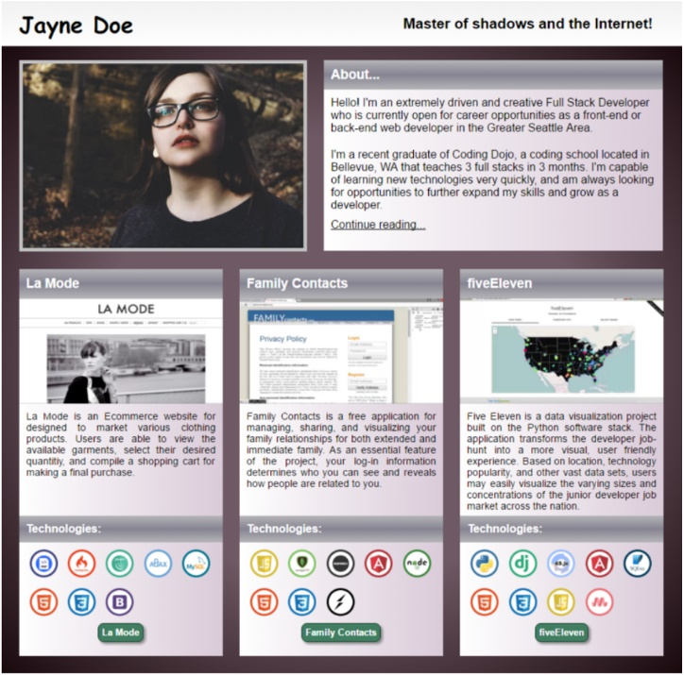

* 1. Repeat columns

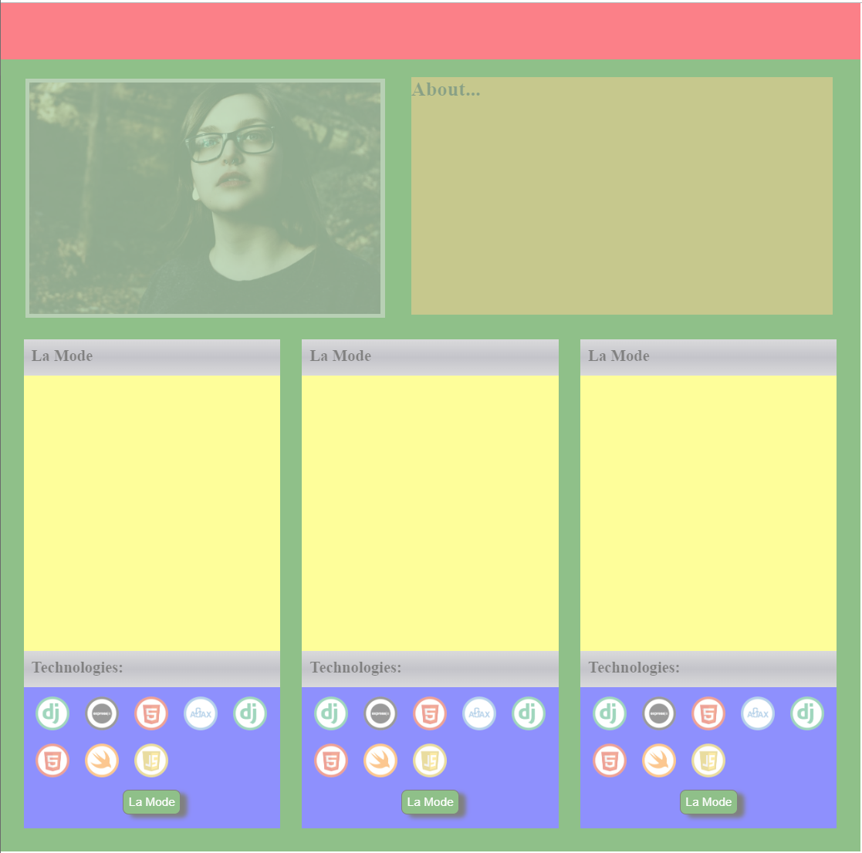

* 1. Add text to first col

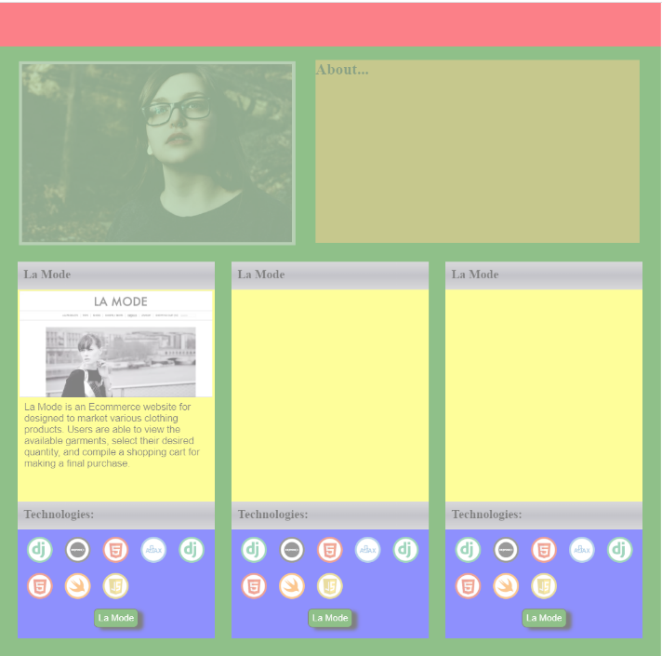 

* 1. Add in background gradient

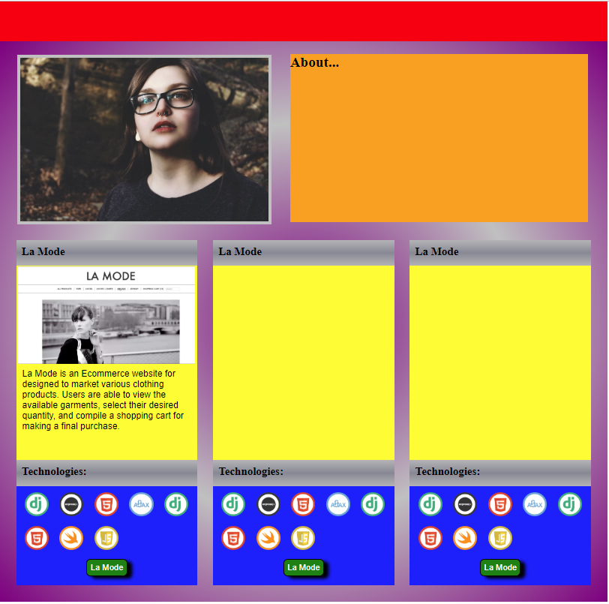

* 1. Add correct text to each column

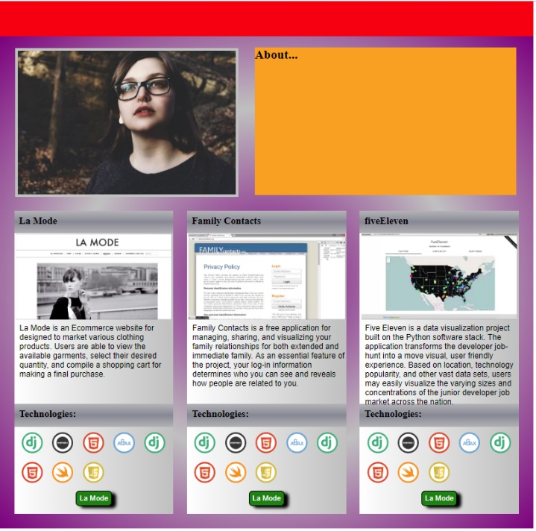 

* 1. Adjust height of main-container

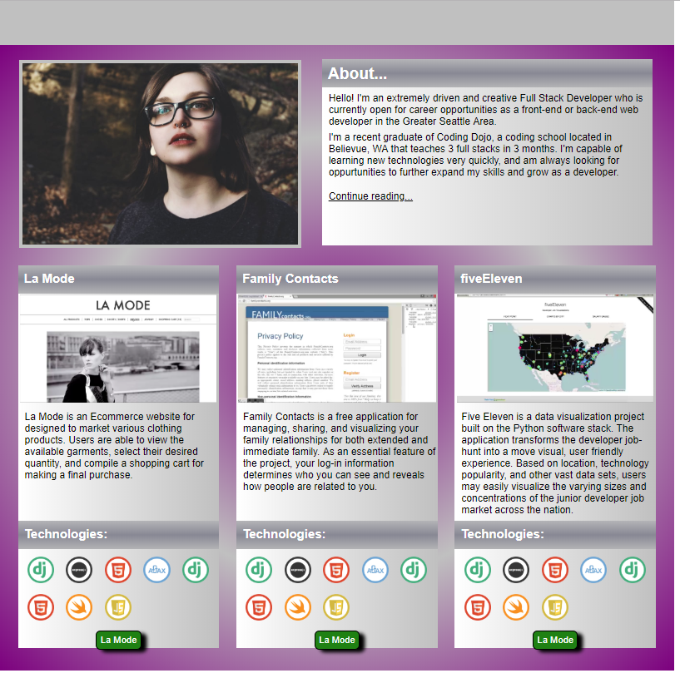

* 1. Fine tune stuff

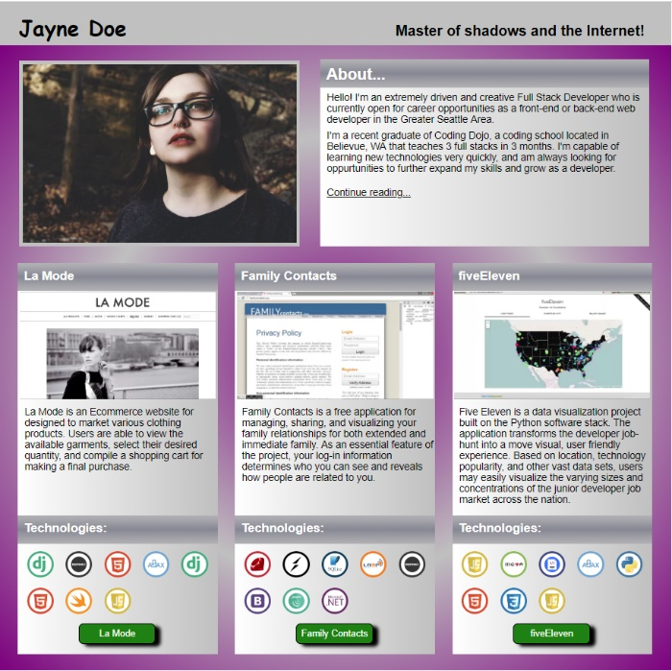 

**Adding a form with CSS styling**



<div>

<div id="text-above-search-bar"></div>

<div id="search-bar">

<form id="search-bar">

<!-- <label for="first_name">First Name: </label> -->

<input type="text" id="search-field" name="SEARCH" value="Search">

<!-- button -->

<input type="submit" id="search-button" name="SEARCH" value="GO">

</form> <!-- search-bar -->

</div>

</div> <!-- end upper-right lego-block -->

/* text above search bar */

#text-above-search-bar {

height: 28px;

/* DEBUG */

background: red;

/* opacity: 0.5; */

}

/* search-bar (form) */

#search-bar {

height: 40px;

padding-top: 10px;

text-align: center;

/* DEBUG */

/* background: yellow; */

/* opacity: 0.5; */

}

/* search-bar field */

#search-field {

text-align: center;

color: silver;

border: silver 1px;

border-style: inset;

}

#search-button {

border-radius: 5px;

background: #245076;

border: 1px silver;

border-style: inset;

color: white;

}

**Centering Un-Ordered List (including bullet points)**

<body>

<main>

<ul class="josh">

<li>a b c d e f g</li>

<li>a b c</li>

</ul>

</main>

</body>

main {

background: blue;

height: 500px;

width: 500px;

}

.josh {

text-align: center;

}

.josh li {

list-style-position: inside;

}

**Adding Shadowing**

…

**Overlay Image**

…

<header>

<img src="images/globe.png" alt="img not found!">

</header>

* {

padding: 0; border: 0; margin: 0; font-family: sans-serif;

}

/* -------------------------------------------------------------------------- */

/* -------------------------------------------------------------------------- */

#container {

/* background: yellow; */

height: 834px;

width: 1000px;

/* DEBUG */

/* background-image: url("spec.png"); background-size: contain; background-repeat: no-repeat; */

}

/* -------------------------------------------------------------------------- */

header {

background: red;

height: 82px;

width: 1000px;

/* DEBUG */ opacity: 0.5;

}

/* -------------------------------------------------------------------------- */

main {

background: blue;

/* DEBUG */ opacity: 0.5;

}

/* -------------------------------------------------------------------------- */

img {

height: 105px;

margin-top: -5px;

}

